TEMPLE DOWNSTAIRS BASEMENT HALL ACTIVITY & ENTRY TIMINGS:

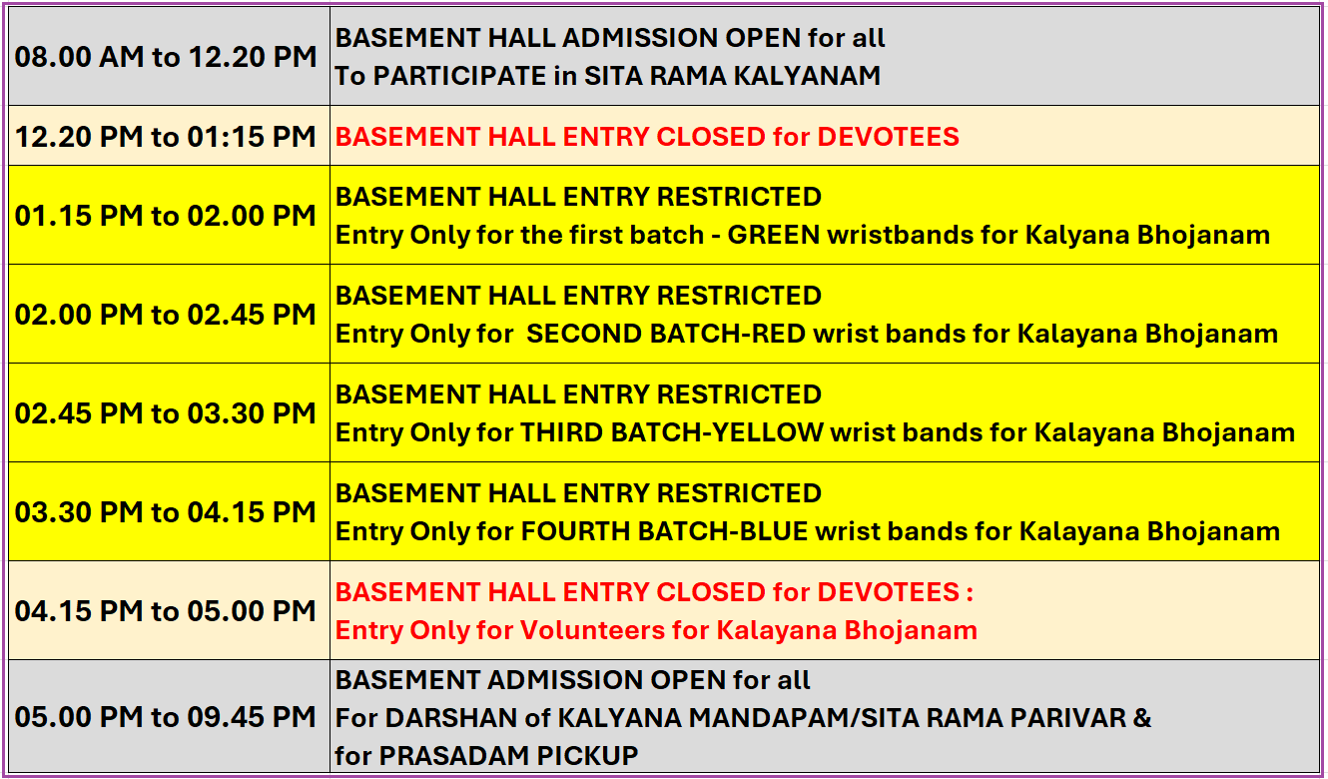
*** All timings are tentative and subject to change
Kalyana Bhojanam (lunch) coupons/wristbands will be issued in the following priority order: first to all Kalyanam participants, then to devotees waiting in the Temple, and finally to those arriving later, until all available (LIMITED – approx. seven hundred) coupons are distributed.
Only one wristband will be issued per devotee present. Children under 2 years of age will require a wristband if they need a separate seat.
If you miss your assigned batch for lunch service you will need to wait till the end
Please follow the instructions of Temple volunteers at all times.

